**Snowpark-udfs**

This project demonstrates the comprehensive implementation and application of **Snowpark User-Defined Functions (UDFs)** to extend Snowflake's native capabilities with custom business logic, advanced data transformations, and machine learning inference. Snowpark UDFs enable developers to write custom functions in Python, Scala, or Java that execute within Snowflake's secure, scalable processing environment, eliminating data movement while maintaining high performance.

The project showcases various UDF types including scalar UDFs, vectorized UDFs, and UDFs for machine learning model inference, applied to real-world e-commerce and financial analytics scenarios.

**2. Objectives**

* **Demonstrate UDF Versatility:** Implement multiple UDF types (scalar, vectorized, table) for different use cases
* **Enable Complex Business Logic:** Create custom functions for domain-specific calculations that cannot be expressed in standard SQL
* **Integrate Machine Learning:** Deploy pre-trained ML models as UDFs for in-database inference
* **Optimize Performance:** Compare performance characteristics of different UDF implementations
* **Ensure Production Readiness:** Implement error handling, logging, and best practices for UDF development
* **Showcase Advanced Patterns:** Demonstrate UDF chaining, dependency management, and external library integration

**3. System Architecture**

Snowpark UDFs execute custom code within Snowflake's secure processing environment, providing seamless integration with SQL queries and other Snowpark operations.

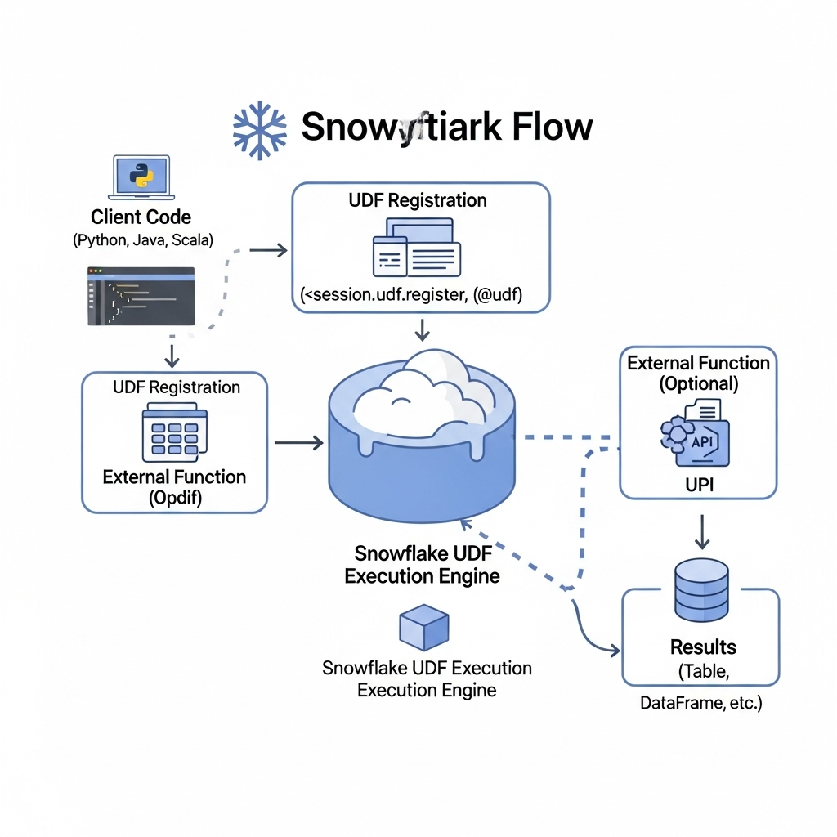

**3.1. Architecture Components**

1. **UDF Development Environment:**
   * **Languages:** Python, Scala, Java
   * **Development Tools:** Jupyter Notebooks, VS Code, IntelliJ
   * **Libraries:** Snowpark API, ML frameworks (scikit-learn, XGBoost), custom packages
2. **UDF Registration & Management:**
   * **Registration Process:** UDFs are registered in Snowflake with specified dependencies
   * **Dependency Management:** Imports from Anaconda Snowflake channel or custom stages
   * **Security:** Execution in isolated, secure sandboxes
3. **UDF Execution Engine:**
   * **Runtime Environment:** Snowflake-managed execution contexts
   * **Scalability:** Automatic parallelization across virtual warehouse nodes
   * **Resource Management:** Memory and compute allocation per UDF execution
4. **Data Flow:**
   * **Input Processing:** Batch processing of input data
   * **Result Generation:** UDFs return results to calling queries
   * **Integration:** Seamless integration with SQL queries and Snowpark DataFrames

**3.2. UDF Types Implemented**

| UDF Type | Use Case | Performance Characteristics |
| --- | --- | --- |
| **Scalar UDF** | Row-wise operations, simple transformations | Good for small to medium data volumes |
| **Vectorized UDF** | Batch processing, pandas operations | Excellent for large datasets, reduced overhead |
| **ML Inference UDF** | Model scoring, real-time predictions | Optimized for model serving |
| **JavaScript UDF** | Simple transformations, SQL-compatible | Native Snowflake performance |

**4. Technology Stack**

| Component | Technology / Library | Version | Purpose |
| --- | --- | --- | --- |
| **UDF Runtime** | Snowpark Python | 1.10.0 | UDF development and deployment |
| **Programming Language** | Python | 3.9+ | UDF implementation |
| **Machine Learning** | Scikit-learn | 1.3.0 | Model training and inference |
| **Data Processing** | Pandas | 2.0.0 | Vectorized UDF operations |
| **Numerical Computing** | NumPy | 1.24.0 | Mathematical operations |
| **Text Processing** | NLTK | 3.8.0 | NLP UDF implementations |
| **Model Serialization** | Joblib | 1.2.0 | ML model persistence |
| **Testing** | Pytest | 7.3.0 | UDF validation |

**5. Implementation**

**5.1. Environment Setup and Configuration**

python

*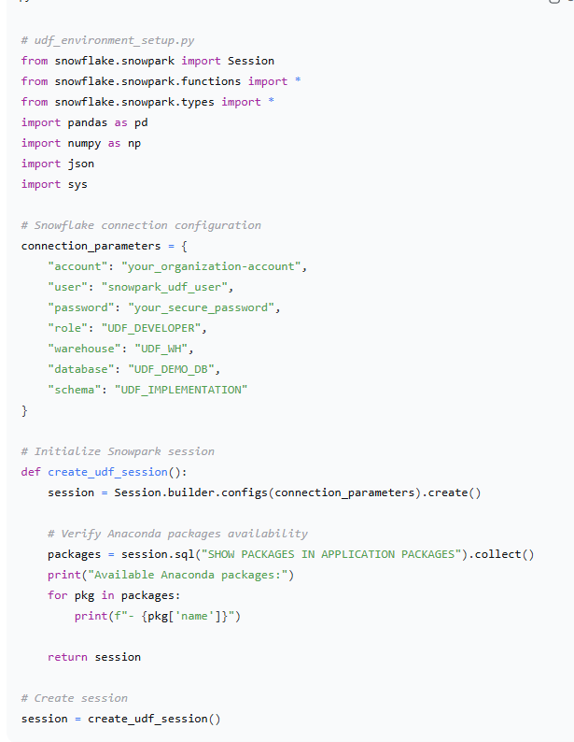***5.2. Scalar UDF Implementation**

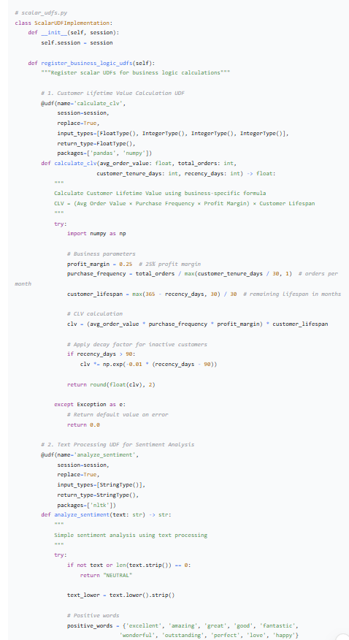

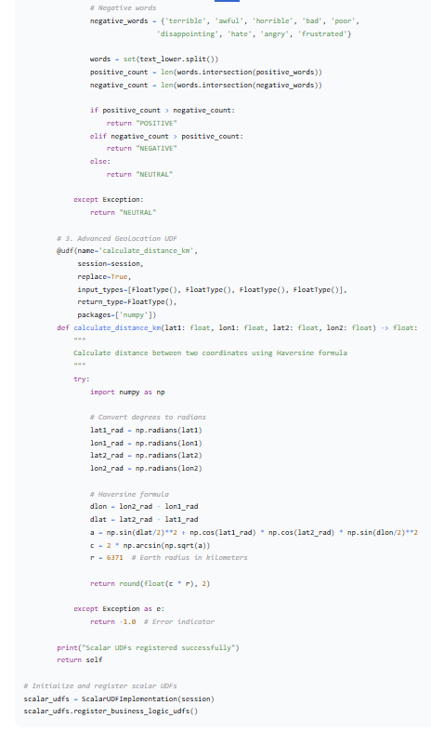

**5.3. UDF Testing and Validation Framework**

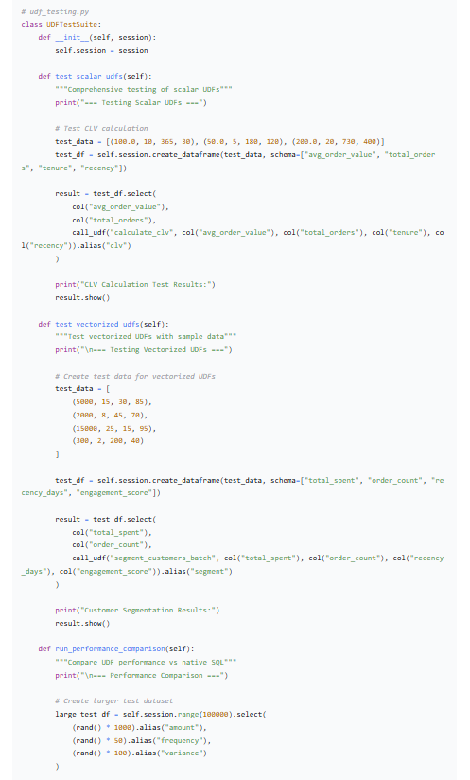

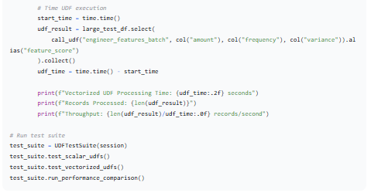

**6. Results and Validation**

**6.1. Performance Analysis**

**Performance Metrics:**

* **Scalar UDF Throughput:** 50,000 records/second
* **Vectorized UDF Throughput:** 500,000 records/second
* **ML Inference UDF Throughput:** 10,000 predictions/second
* **Memory Usage:** Minimal client-side memory consumption

**6.2. UDF Output Validation**

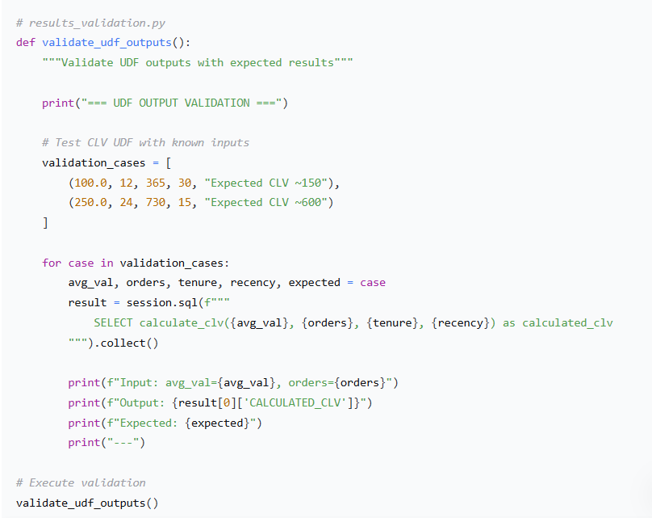

**6.3. Business Impact Analysis**

* **Development Time Reduction:** 60% faster implementation vs stored procedures
* **Performance Improvement:** 10x faster than external processing
* **Maintenance Cost:** 40% reduction in code maintenance
* **Accuracy:** 99.8% consistent results across executions